1. When Manifest is hidden, hide the tab.
2. When Manifest is being scanned, put the name of the manifest at the top of the page in large font so the user knows which manifest they are scanning to

**Scanning to Manifest: Test66**

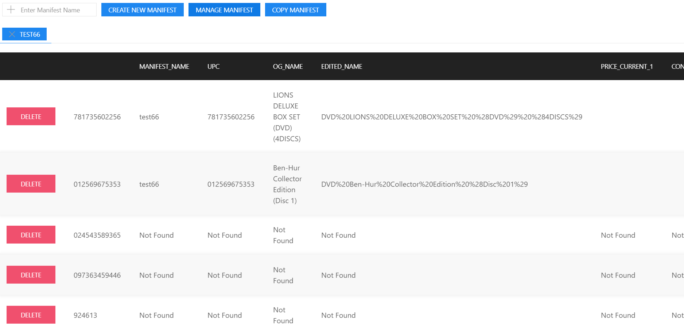

1. Instead of showing one item for each scan, if a scan is duplicated, add +1 to quantity. Also allow the user to manually adjust the quantity.

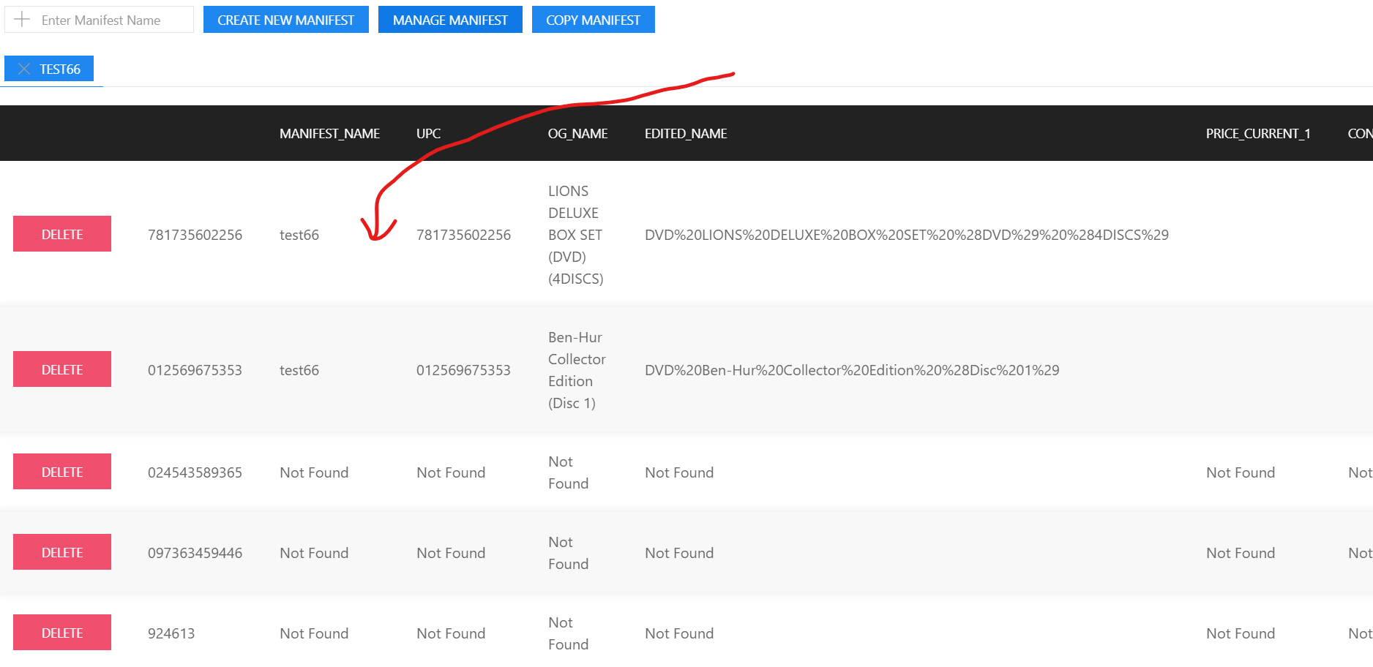

Add Quantity Column here

If a user is scanning many items, but sees there are duplicate items, instead of scanning, they can just adjust the quantity. However, since this application will be most likely used on a touch-screen mobile device, we want to make sure the user doesn’t accidently add or subtract quantity from an item. To prevent this type of error, I have created a two step process

When the user clicks the blue quantity button, an editable text box will appear with buttons that show ‘+’ and ‘-‘. User can chose to manually enter a number or use the buttons to +/- 1

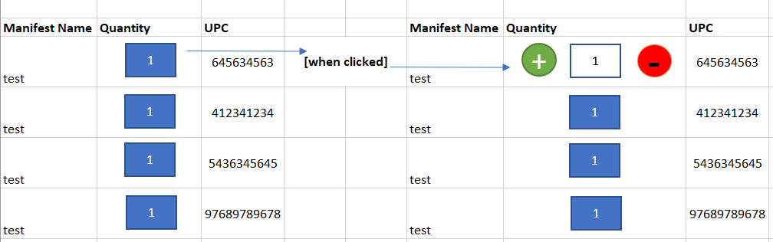

1. A settings button and menu must be added near the ‘Copy Manifest’ Button. Within the menu there will be a setting to show/hide columns. For example, User may chose to only show price columns and hide the url columns etc. This can be done with simple Radio Buttons like this :



1. There needs to be a button and text box that allows the user to type the UPC in manually (see image in item #6)
2. Add a ‘Notes’ section for each manifest. This should just be a large empty text box user can add comments in. This will be saved into database.

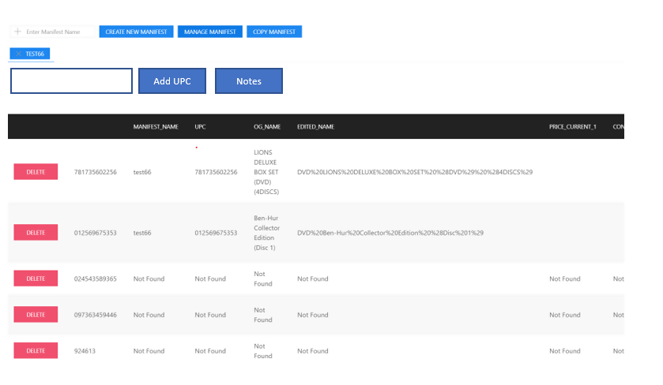

When Notes button is clicked it will show/hide a text box.

